PCO DIAGNOSTIC AND FOLLOW-UP SHEET
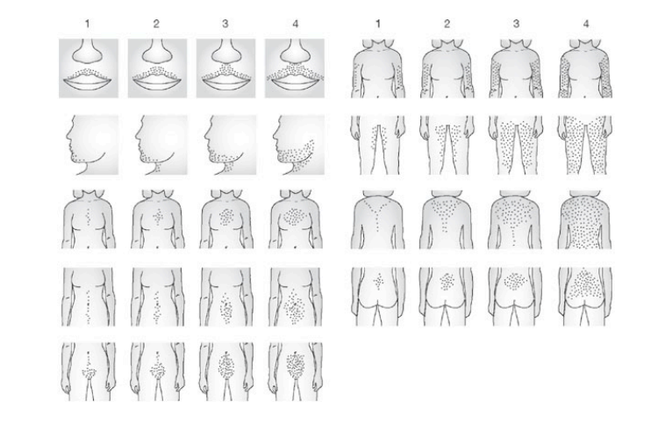
NAME: | MRD:
HISTORY OF INFERTILITY: Yes No | USE OF CONTRACEPTION: Yes No
H/O LOW BIRTH WEIGHT: Yes No | NEED FOR LOW-BIRTH WEIGHT: Yes No
H/O ANXIETY/DEPRESSION: Yes No | BODY IMAGE ISSUES: Yes No
SUDDEN WEIGHT CHANGES: Yes No | FAMILY H/O DM II: Yes No
FIRST DEGREE MALE RELATIVES’ HISTORY: Father Brother :
BOOKING VISIT FINDINGS
PHENOTYPE: A B  C D | Height: cm | Weight: kg
TYPE OF OBESITY: Not Obese  Global(A) Android(B)  Central(C) Gluteo-Femoral(D) | BMI: kg/m² | WC: cm
 | HC: cm | WHR:
FERRIMAN GALLWEY SCORE: | NC: cm
METABOLIC SYNDROME: Yes No | AN: Yes No | BP: mm Hg
RISK OF OSA: Yes No BERLIN TOOL: STOP BANG:

PSYCO-SEXUAL FUNCTION : Normal Affected | SCOFF TOOL: Normal High-risk
ASCVD RISK: | JBS3 CALCULATOR:
CATEGORY | BMI |  | PARAMETERS ( >3)
Underweight | <18.5 |  | TG > 150 mg/dl
Normal | 18.5-24.9 |  | WC >102 in males and >88 in females
Over Weight | 25-29.9 |  | HDL <40 in males and <50 in females
Grade 1 Obseity | 30-34.9 |  | BP > 130/85
Grade 2 Obesity | 35-39.9 |  | FBS > 110
Grade 3 Obesity | 40

TYPE | PARTICULARS
TYPE 1 | Excess body fat without any particular pattern | Global Obesity
TYPE 2 | Excess subcutaneous fat especially in trunk and abdomen | Android Obesity (WHR > 0.8)
TYPE 3 | Excess of fat in the abdominal viscera
TYPE 4 | Excess of fat in gluteo femoral region | (WHR < 0.8)

 | A | B | C | D
 | HA/OD/PCO | HA/OD | HA/PCO | OD/PCO
HA | + | + | + | -
OD | + | + | - | +
PCO | + | - | + | +
HA: Hyperandrogenism
OD: Ovulatory Dysfunction
PCO: Polycystic Ovaries

Date of visit: | PARAMETER  (every visit) |  | EXAMINATION  (every visit) |  | BLOOD TESTING  (Annually) |  | LIPID PROFILE  (every 2 years if normal)
 | LMP |  | PR | bpm | HbA1c |  | Lipid profile
 | MENSTRUAL REGULARITY | Regular Irregular | BP | mm Hg | FBS
 | USE OF ANY MEDICINE |  | WEIGHT | kg | PPBS
 | ANY PRESENT COMPLAINTS |  | BMI | Kg/m²
 | NEED FOR CONTRACEPTION | Yes No | WHR |  | ADDITIONAL TESTS  (as and when required)
 | DESIRE FOR FERTILTY | Yes No | HYPER-ANDROGENISM | Yes No
 | HYPERANDROGENISM | Yes No | FERRIMAN GALLWEY SCORE
 |  |  | FEATURES OF HYPER-INSULINEMIA | Yes No

Date of visit: | PARAMETER  (every visit) |  | EXAMINATION  (every visit) |  | BLOOD TESTING  (Annually) |  | LIPID PROFILE  (every 2 years if normal)
 | LMP |  | PR | bpm | HbA1c |  | Lipid profile
 | MENSTRUAL REGULARITY | Regular Irregular | BP | mm Hg | FBS
 | USE OF ANY MEDICINE |  | WEIGHT | kg | PPBS
 | ANY PRESENT COMPLAINTS |  | BMI | Kg/m²
 | NEED FOR CONTRACEPTION | Yes No | WHR |  | ADDITIONAL TESTS  (as and when required)
 | DESIRE FOR FERTILTY | Yes No | HYPER-ANDROGENISM | Yes No
 | HYPERANDROGENISM | Yes No | FERRIMAN GALLWEY SCORE
 |  |  | FEATURES OF HYPER-INSULINEMIA | Yes No

